Exp.No-1

- Perform basic Image Handling and processing operations on the image.
• Read an image in python and Convert an Image to Grayscale
Aim:
To read an image and convert it into a grayscale image using OpenCV.

Algorithm:
- Start the program.
- Import the OpenCV library.
- Read the input image.
- Convert the image to grayscale.
- Display the original and grayscale images.
- Save the grayscale image.
- Stop the program.
Program:
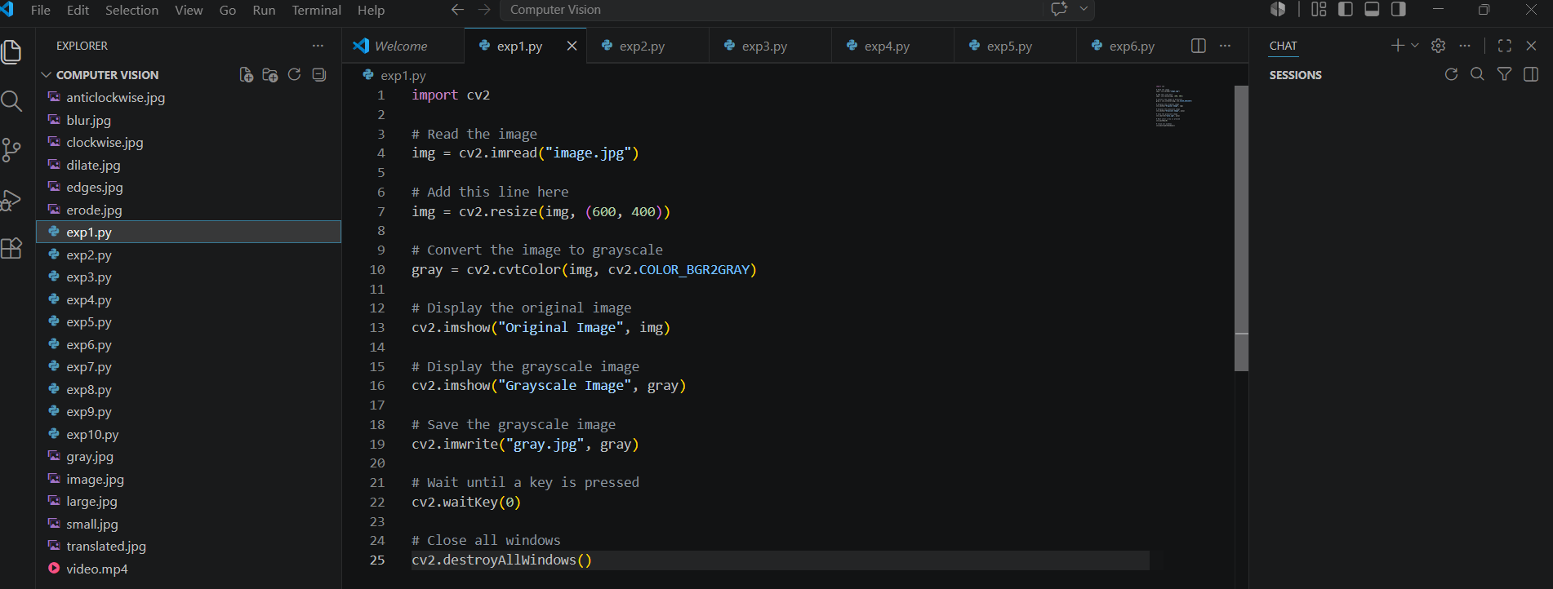

Input:
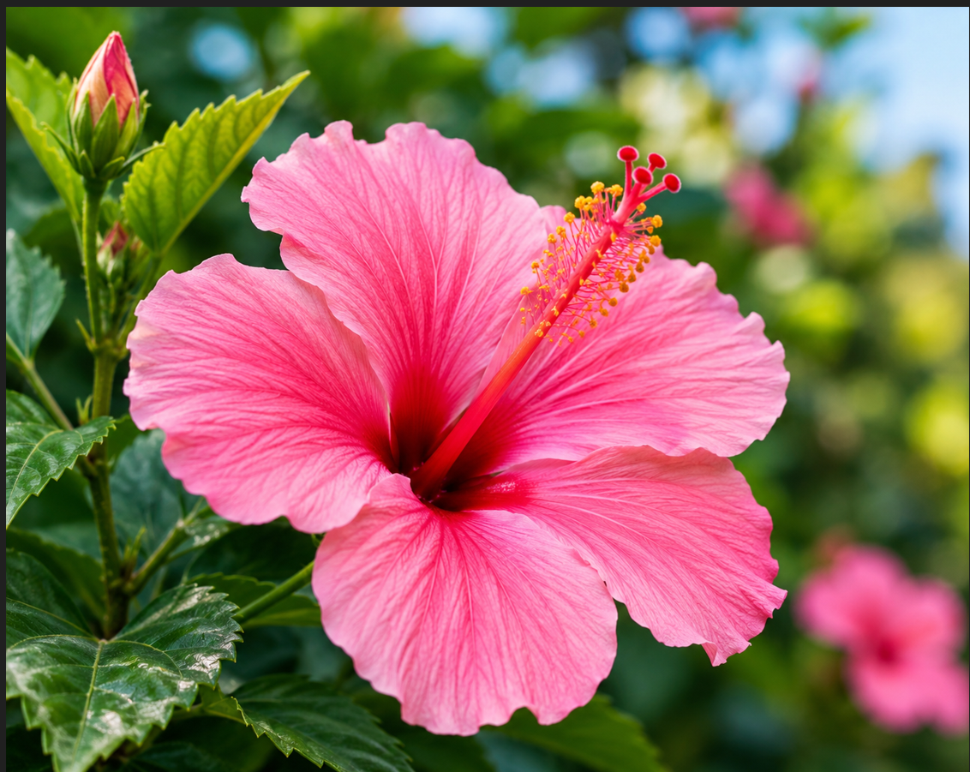

Output:
